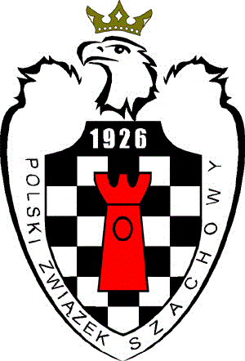
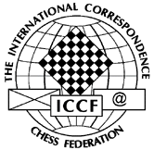

Announcement
for Match Witold's Friends - Rest of the World

Dear Friends,

The International Correspondence Chess Federation is delighted to announce the Correspondence Chess Commission of the Polish Chess Federation as the main organizer of the friendly match Witold's Friends - Rest of the World.

Performing ICCF activities many of you knew Witold Bielecki (28.02.1947 - 05.04.2008) personally or from the distance.
Just few words about him.
He was chairman of the Polish Correspondence Chess Federation and Polish delegate to ICCF, correspondence chess player and official since 1964, IM since 1996 and IA since 1978, member and chairman of several ICCF working groups and committees/ commissions (Tournaments, Tournament Rules, Playing Rules, Appeals).
He performed function as a national team captain many times. He directed hundreds of tournaments, including eight editions of World Championship final (from 15 to 23, except of 19).
He laid down main effort as TO and TD for three World Cups (3rd, 6th and 7th) with total amount of 6.222 (sic!) entries.
During ICCF Congress 1998 in Riga (Latvia) he was awarded with "Bertl von Massow" medal in Gold for 15 years meritorious work for ICCF.
He cooperated with "Fernschach" for many years.
Witek left his wife Teresa and his son Robert and all of us unexpectedly, in the prime of his life.
He was our great chess friend. He put his soul and his spare time into his work for correspondence chess. Always ready to assist you.

In gratitude for his effort let us participate in this friendly match.

This match will be organized in a standard format with one opponent for each player and two games to play (one game with white and one game with black) and will be played on the ICCF webserver with a rate of play of 10 moves in 50 days. The event will be rated.

The tournament will start on 01.03.2012 with no end date.
Registration will begin 01.08.2011 and will close on 01.02.2012 to allow for pairings.

Players may enter in the usual way through their National Federations or directly to the organizer.
Entries should contain player’s name, email address, ICCF ID and wish to join specific team and should be forwarded by email to the Match Organizer, Mariusz Wojnar, email: mariusz.wojnar@gmail.com to reach him before 1st February 2012.

Allocation of players to specific team will be made as random as possible; however, geographical distribution as well as an achievement of reasonable difference in rating and wish to join specific team, will be taken into account.

We wish all participants many interesting games and new connections with CC friends in other countries, based on the spirit of friendship and the ICCF motto:
AMICI SUMUS

Mariusz Wojnar  Match Organizer |  | Eric Ruch  ICCF President

